**DAILY ONLINE ACTIVITIES SUMMARY**

|  |  |  |  |  |  |  |  |
| --- | --- | --- | --- | --- | --- | --- | --- |
| **Date:** | **11-06-2020** | | | | **Name:** | **Rani M.D** | |
| **Sem & Sec** | **6th - B** | | | | **USN:** | **4AL17CS075** | |
| **Online Test Summary** | | | | | | | |
| **Subject** | **PAP Assignment test 3** | | | | | | |
| **Max. Marks** | **20** | | **Score** | | | **18** | |
| **Certification Course Summary** | | | | | | | |
| **Course** | **TCS Carrier edge** | | | | | | |
| **Certificate Provider** | | **TCS** | | **Duration** | | | **15 days** |
| **Coding Challenges** | | | | | | | |
| **Problem Statement:1Java program 1 Python program** | | | | | | | |
| **Status: Executed** | | | | | | | |
| **Uploaded the report in GitHub** | | | | **yes** | | | |
| **If yes Repository name** | | | | Daily Status | | | |
| **Uploaded the report in slack** | | | | **Yes** | | | |

Online Test Details: (Attach the snapshot and briefly write the report for the same)

Third Assignment test of PAP

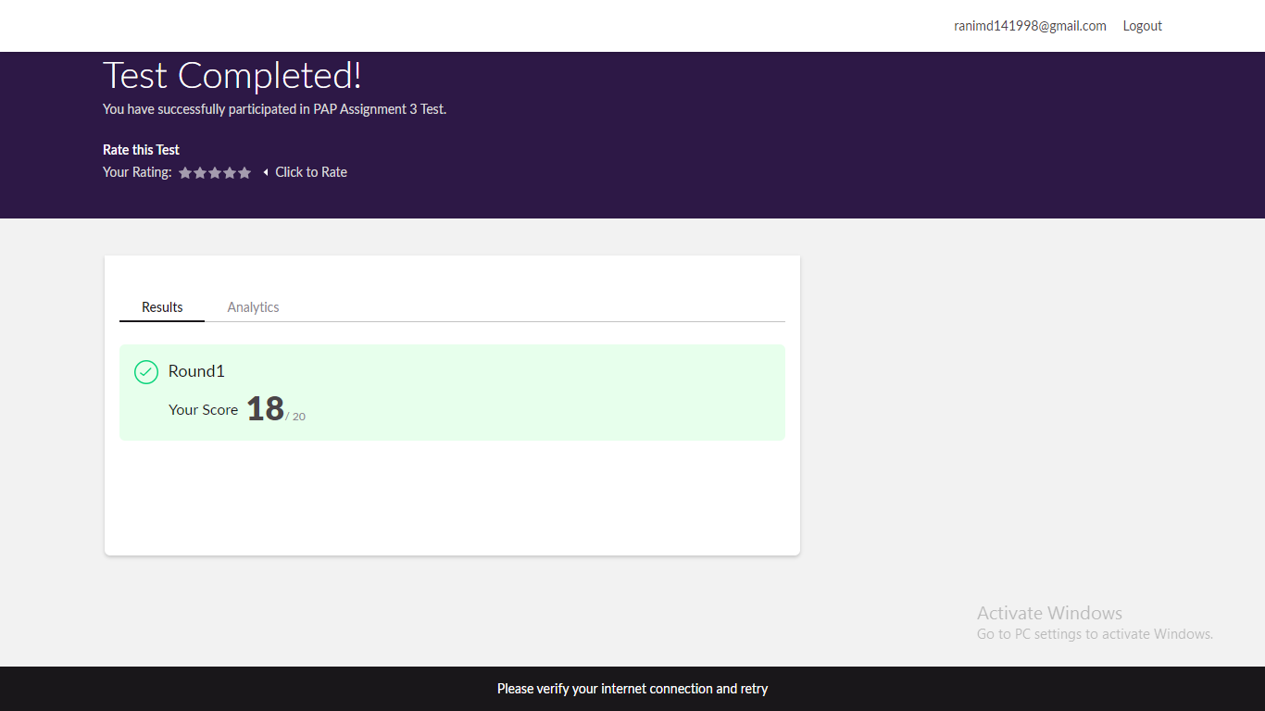

Certification Course Details: (Attach the snapshot and briefly write the report for the same)

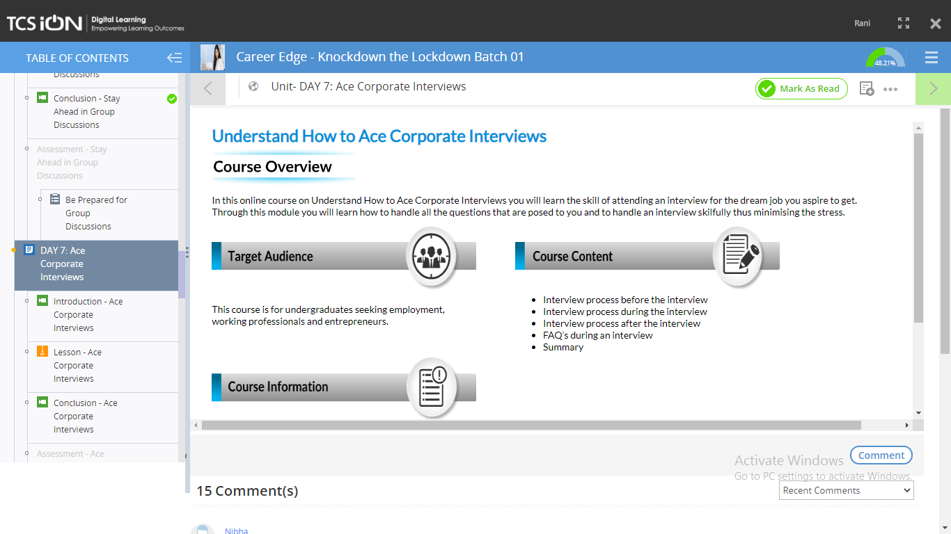



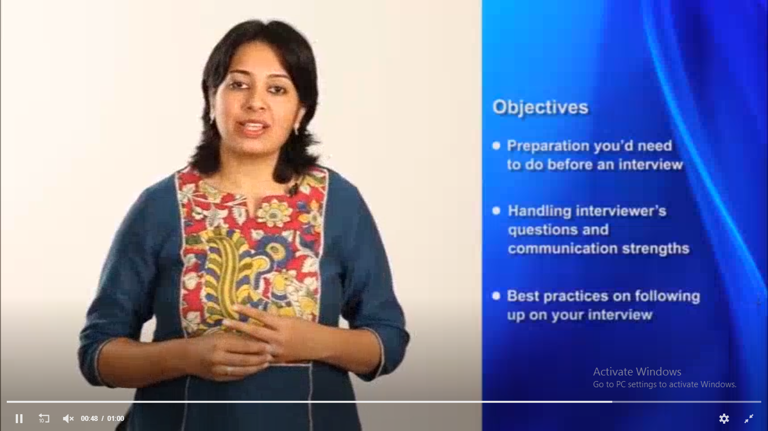



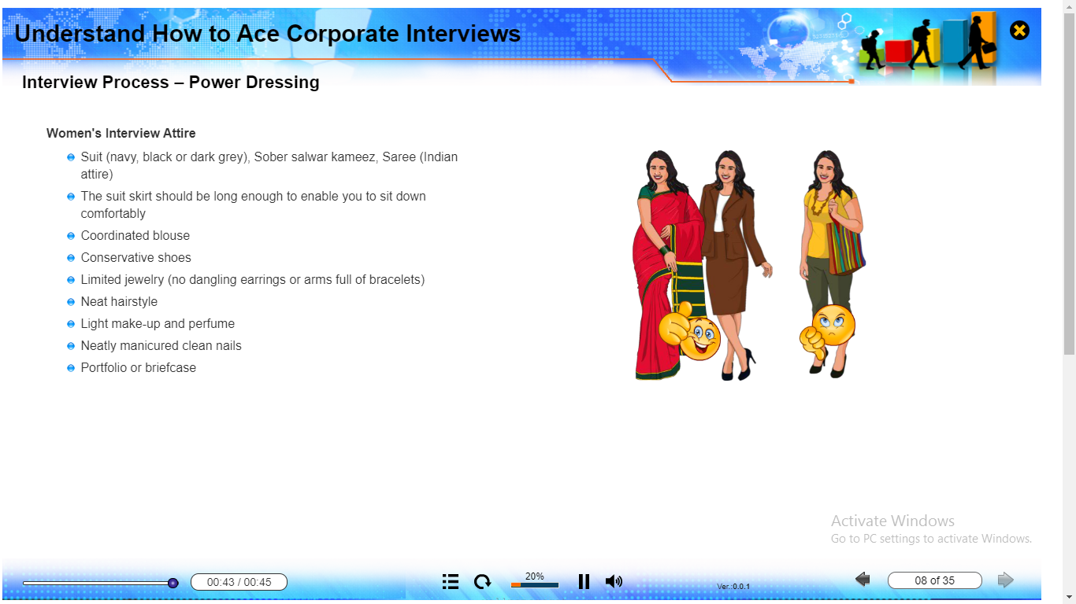

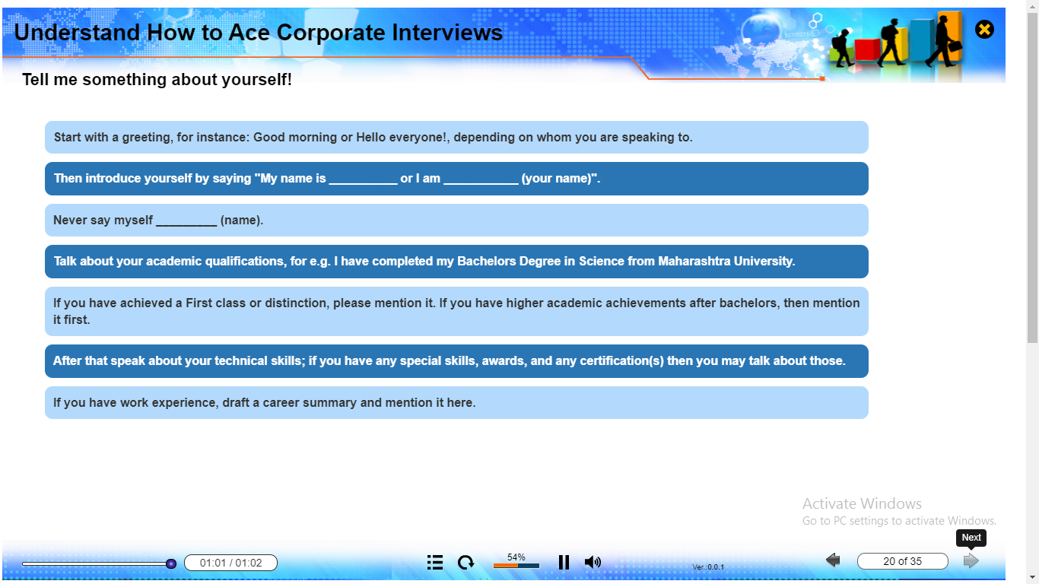

Coding Challenges Details: (Attach the snapshot and briefly write the report for the same

Output screen shots

1. Subject: Write a Java program to find the nodes which are at the maximum distance in a Binary Tree

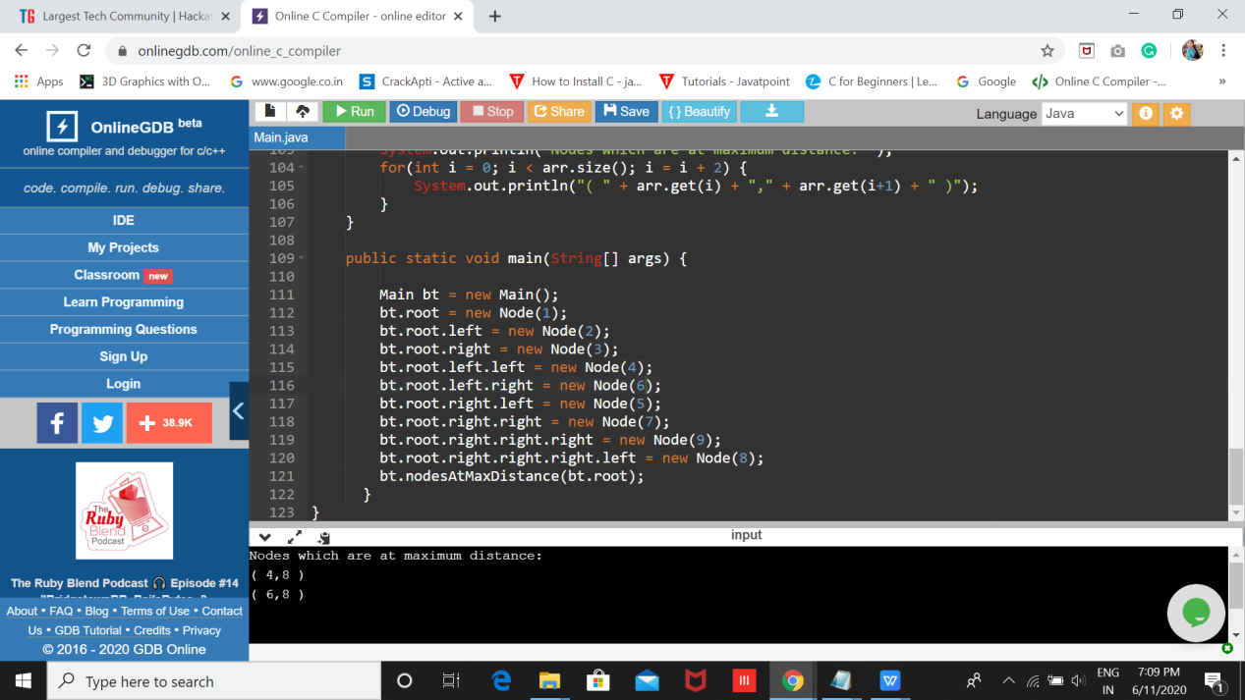

1. Write a python function that converts a string to all uppercase, provided it contains at least 2 uppercase characters in the first 4 characters. Else print the string as it is

